**STRUCTURE OF US BANKING SYSTEM**

A dual banking system is the type that exists in the United States, in which State Banks and National banks are Chartered and supervised at different levels of government.

Under the U.S. dual banking system, national banks are chartered and regulated under federal law and supervised by federal agencies. State banks are chartered and regulated under state laws and supervised by their respective states’ banking departments. The dual system is not perfectly clear-cut, however, with some state banks answering to regulators on both levels.

**KEY TAKEAWAYS**

* The United States has a dual banking system, with national banks regulated on the federal level and state banks regulated by each state.
* There is some overlap between the two systems, with certain state banks subject to regulation on both levels.
* Proponents of the dual banking system maintain two pros: that national banks benefit from their greater scale, while state banks can be more innovative and attuned to the needs of their communities, and that the two types complement each other.
* A con of the dual banking system is that it adds a certain level of complexity for bankers and consumers that wouldn’t exist in a single banking system.

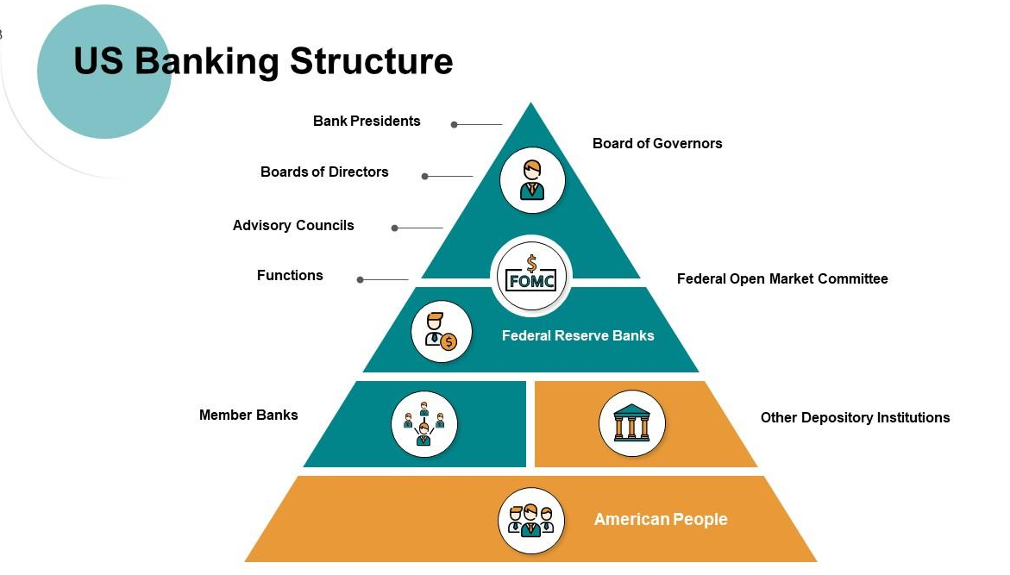

While most countries have only one bank regulator, in the U.S., banking is regulated at both the federal and state levels. Depending on its type of charter and organizational structure, a banking organization may be subject to numerous federal and state banking regulations.

Mentioned below are the regulatory agencies:

**Federal Reserve system**

The [Federal Reserve](https://en.wikipedia.org/wiki/Federal_Reserve_System) is the [central bank](https://en.wikipedia.org/wiki/Central_bank) of the United States.

The [central banking](https://en.wikipedia.org/wiki/Central_bank) system of the United States, called the [Federal Reserve system](https://en.wikipedia.org/wiki/Federal_Reserve_system), was created in 1913 by the enactment of the [Federal Reserve Act](https://en.wikipedia.org/wiki/Federal_Reserve_Act), largely in response to a series of financial panics, particularly a severe [panic in 1907](https://en.wikipedia.org/wiki/Panic_of_1907).[[6]](https://en.wikipedia.org/wiki/Banking_in_the_United_States#cite_note-mnglass-6)[[7]](https://en.wikipedia.org/wiki/Banking_in_the_United_States#cite_note-initial-7) Over time, the roles and responsibilities of the Federal Reserve System have expanded and its structure has evolved.[[8]](https://en.wikipedia.org/wiki/Banking_in_the_United_States#cite_note-initial2-8) Events such as the [Great Depression](https://en.wikipedia.org/wiki/Great_Depression) were major factors leading to changes in the system.[[9]](https://en.wikipedia.org/wiki/Banking_in_the_United_States#cite_note-patrick-9) Its duties today, according to official Federal Reserve documentation, are to conduct the nation's monetary policy, supervise and regulate banking institutions, maintain the stability of the financial system and provide financial services to [depository institutions](https://en.wikipedia.org/wiki/Depository_institution), the [U.S. government](https://en.wikipedia.org/wiki/U.S._government), and foreign official institutions

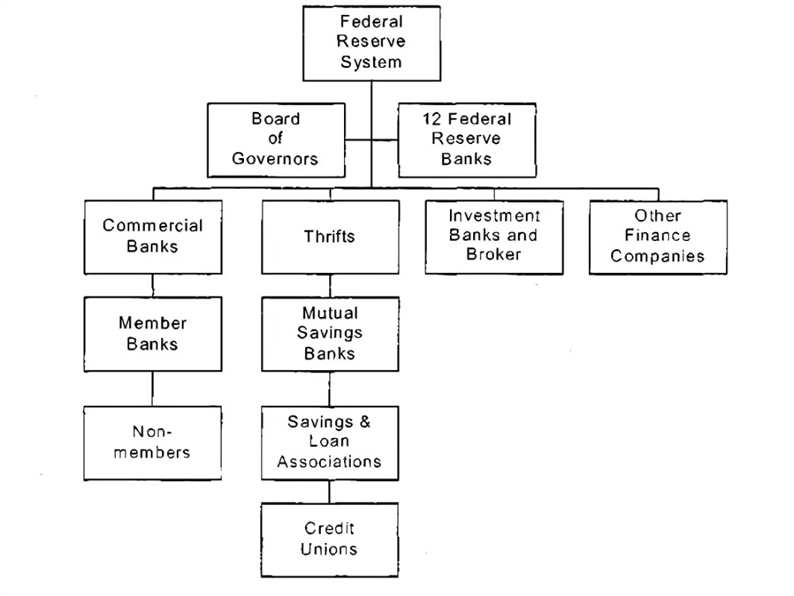

**Functions:**

* Monetary Policy: The Fed influences interest rates, controls inflation, and promotes economic growth by adjusting the money supply.
* Bank Supervision: It supervises and regulates banks to ensure their safety and soundness.
* Financial Services: The Fed provides services to financial institutions, including clearing checks and facilitating electronic payments.
* Currency Issuance: It oversees the issuance and circulation of currency.
* [Emergency Lending: During crises, the Fed can lend to financial institutions to stabilize the economy](https://www.businessinsider.com/personal-finance/what-is-the-federal-reserve).

**Federal Deposit Insurance Corporation**

The Federal Deposit Insurance Corporation (FDIC) is a [United States government corporation](https://en.wikipedia.org/wiki/Government-owned_corporation#United_States) created by the [Glass–Steagall Act](https://en.wikipedia.org/wiki/Glass%E2%80%93Steagall_Act) of 1933. It provides [deposit insurance](https://en.wikipedia.org/wiki/Deposit_insurance), which guarantees the safety of deposits in member banks, up to $250,000 per [depositor](https://en.wikipedia.org/wiki/Deposit_account) per bank.

As of November 18, 2010, the FDIC insured deposits at 6,800 institutions. The FDIC also examines and supervises certain financial institutions for safety and soundness, performs certain consumer-protection functions, and manages banks in receivership (failed banks). Since the start of FDIC insurance on January 1, 1934, no depositor has lost any insured funds as a result of a bank failure.

**Office of the Comptroller of the Currency**

The Office of the Comptroller of the Currency (OCC) is a U.S. federal agency established by the [National Currency Act of 1863](https://en.wikipedia.org/wiki/National_Currency_Act_of_1863) and serves to charter, regulate, and supervise all [national banks](https://en.wikipedia.org/wiki/National_bank_(United_States)) and the federal branches and agencies of foreign banks in the United States. Thomas J. Curry was sworn in as the 30th Comptroller of the Currency on April 9, 2012.

**Office of Thrift Supervision**

The Office of Thrift Supervision is a [U.S. federal agency](https://en.wikipedia.org/wiki/List_of_United_States_federal_agencies) under the Department of the Treasury. It was created in 1989 as a renamed version of another federal agency (that was faulted for its role in the [Savings and loan crisis](https://en.wikipedia.org/wiki/Savings_and_loan_crisis)). Like other U.S. federal bank regulators, it is paid by the banks it regulates. On July 21, 2011, the Office of Thrift Supervision became part of the Office of the Comptroller of the Currency.

US BANKING SYSTEM

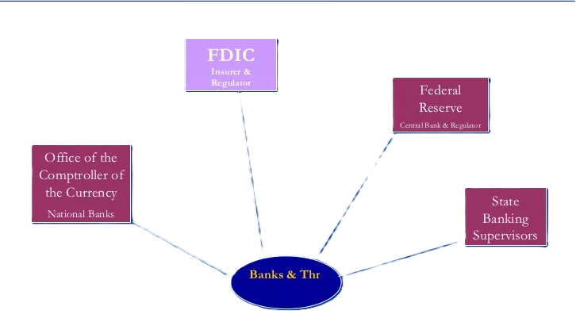

**Revenue generation**

Revenue generation in the United States involves various sources.

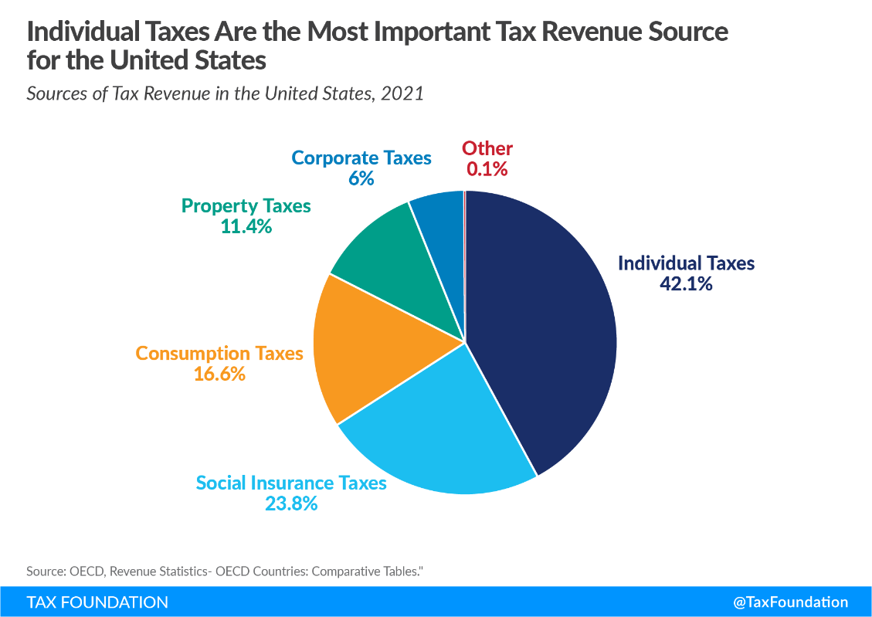

**Differences and Similarities between Indian and US banking system**

The banking systems in India and the United States have both similarities and differences rooted in their unique economic structures, regulatory environments, and historical developments.

While both India and the U.S. have well-developed banking systems with modern technological integration and regulatory oversight, the differences largely stem from the structure and ownership of banks, regulatory approaches, and specific national priorities such as financial inclusion and sectoral lending mandates. Both systems strive to ensure financial stability and serve the needs of their respective economies, albeit through slightly different mechanisms and regulatory frameworks.

### Similarities

#### 1. **Central Banking Authority**

* **India**: Reserve Bank of India (RBI).
* **U.S.**: Federal Reserve System (The Fed).
* **Function**: Both central banks regulate monetary policy, oversee the banking sector, issue currency, and aim to maintain financial stability.

#### 2. **Types of Financial Institutions**

* **Commercial Banks**: Both countries have a mix of public sector (government-owned) and private sector commercial banks providing similar services such as accepting deposits, providing loans, and offering financial services.
* **Cooperative Banks and Credit Unions**: In India, cooperative banks serve similar functions to credit unions in the U.S., focusing on member-based, community-oriented banking services.

#### 3. **Regulatory Framework**

* **Multiple Regulatory Bodies**: Both countries have multiple regulatory agencies that oversee different aspects of the banking system. For instance, India has the RBI, SEBI (Securities and Exchange Board of India), and IRDAI (Insurance Regulatory and Development Authority of India), while the U.S. has the Federal Reserve, FDIC (Federal Deposit Insurance Corporation), OCC (Office of the Comptroller of the Currency), and SEC (Securities and Exchange Commission).

#### 4. **Technological Advancements**

* **Digital Banking**: Both banking systems have embraced digital banking, with widespread use of online and mobile banking services.
* **Fintech Integration**: Fintech companies in both countries are increasingly collaborating with traditional banks to offer innovative financial products and services.

### Differences

#### 1. **Banking Structure and Ownership**

* **India**: A significant portion of the banking sector is dominated by public sector banks (PSBs) owned by the government. Major examples include State Bank of India (SBI) and Punjab National Bank (PNB).
* **U.S.**: The banking sector is primarily dominated by private banks, with major players like JPMorgan Chase, Bank of America, and Wells Fargo being privately owned.

#### 2. **Regulatory Approach**

* **India**: The RBI plays a central and dominant role in regulating all aspects of the banking system, including monetary policy, supervision of banks, and financial stability.
* **U.S.**: The regulatory framework is more fragmented, with multiple federal and state-level agencies overseeing different aspects of banking and finance. For example, the Federal Reserve handles monetary policy, the FDIC insures deposits, and state regulators oversee state-chartered banks.

#### 3. **Financial Inclusion**

* **India**: There is a strong focus on financial inclusion, with initiatives like Pradhan Mantri Jan Dhan Yojana (PMJDY) aimed at ensuring every household has access to banking services.
* **U.S.**: While financial inclusion is a goal, it is not as prominently emphasized at the national policy level. Community development banks and credit unions often play a significant role in this area.

#### 4. **Deposit Insurance**

* **India**: Deposit insurance is provided by the Deposit Insurance and Credit Guarantee Corporation (DICGC), covering deposits up to ₹5 lakh (approximately $6,600).
* **U.S.**: The FDIC provides deposit insurance covering deposits up to $250,000 per depositor, per insured bank.

#### 5. **Interest Rate Policies**

* **India**: The RBI directly controls key policy rates such as the repo rate and reverse repo rate, which influence the lending rates of banks.
* **U.S.**: The Federal Reserve influences interest rates primarily through the federal funds rate, which indirectly affects other interest rates across the economy.